WHAT IS THE VAKS PROGRAMME?
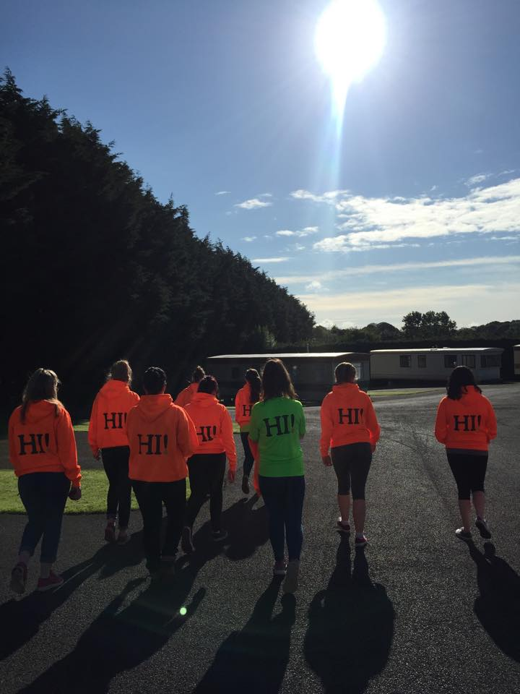
We are inviting YOU to be part of Knock Shrine and volunteer for one weekend of the summer. Over the weekend you will meet new people, welcome pilgrims and help the people who visit Knock.
The Volunteer @ Knock Shrine programme is for all people over 16 years old. It is an opportunity for you to serve the pilgrims at Knock Shrine. Over 1.4 million people visit Knock Shrine every year from home and abroad. It is a special place of prayer and pilgrimage. The cost of the programme is €30. This includes all your food and accommodation for the weekend and a t-shirt.
WHY VOLUNTEER?

- Volunteering can add a great deal to your life and to the lives of those you are working with.
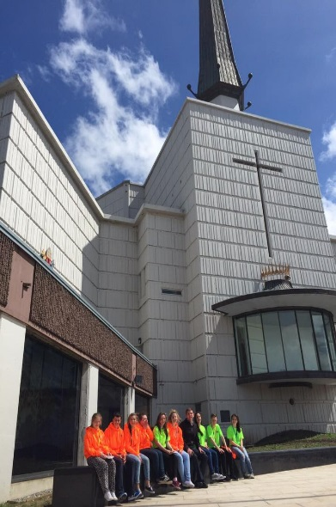
- It also gives you the chance to try out something different to your ‘everyday’ job.
- To form new friendships
- To develop/acquire interpersonal skills
- To have fun!
- To enhance your skillset/experience for University and employment
- To share your talents
- To receive recognition for your voluntary hours of service through the John Paul II awards
- To give something back
- To make a difference in the lives of others
- To obtain training in areas such as Child Safeguarding and Protection and/or First Aid
- Volunteering provides many benefits to both mental and physical health
HOW DOES IT WORK?
You will need to attend training days at Knock before you can volunteer, training includes the following:
- Communication skills
- Manual Handling
- Basic First Aid
- Child Protection
- Youth Ministry
- Team Building
- Prayer & Reflection
- Liturgy & Spirituality of Knock Shrine
- The Story of Knock
- Sign Language

Training will run on the 24th of May from 10am – 5:30pm. Training is essential to take part in the VAKS programme. If necessary alternative dates will be available for leaving cert students
Once training is complete you can then choose the weekend that you would be available to volunteer for.
PLEASE FILL IN BLOCK CAPITALS
Name _________________________________________
Gender: Male Female
Address: ______________________________________
______________________________________
Postcode_____________
Mobile: ________________________________________
DOB: __________________________________________
E: Mail: _________________________________________
T- Shirt Size: XS M XL L XL

Have you volunteered before? If yes, please give a brief description of the work involved
______________________________________________________________________________________________________________________________________________________________________________________________________________________________
Why do you want to volunteer at Knock?
______________________________________________________________________________________________________________________________________________________________________________________________________________________________
What are your gifts & talents? ______________________________________________________________________________________________________________________________________________________________________________________________________________________________
Tell us more about yourself? Hobbies etc. ____________________________________________________________________________________________________________________________________________________
____________________________________________________________________________________________________________________________________________________
REFERENCES
Please provide the name of two people whom Knock Shrine can contact for a reference (not relatives):
Name: _______________________ Name: _____________________________
Address: ______________________ Address ______________________________
_____________________________ ______________________________________
Number: _____________________ Number ____________________________
E: mail: ______________________ E: mail: _____________________________

Your privacy is important to us. As part of the new Data Protection legislation governing Ireland, we are required to keep a record of your consent to process your personal data. Your personal data includes your name, email address, address and phone number. We will only keep your personal data for as long as it is necessary and it will not be passed on to any unauthorised third parties.
I give consent for Knock Shrine to process my personal data
I declare that the above information is true and I am fit to serve as a volunteer.
Signed: _______________________ Date: _______________________
Please fill Garda Vetting & return along with this form. This is necessary to take part in the VAKS programme

